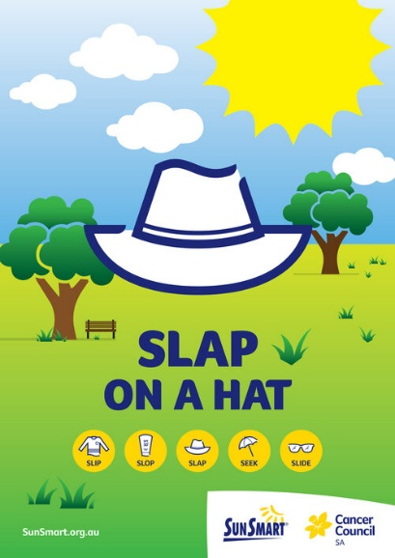It’s time to be SunSmart!

September marks the start of the SunSmart season in Tasmania. We need to protect ourselves from the sun when the UV is 3 or above.

**That means it’s time to dust off your hats, slip on a long-sleeved shirt and grab your sunglasses and sunscreen to protect yourself when outside in the sun.**

For more information, visit <https://www.cancer.org.au/cancer-information/causes-and-prevention/sun-safety>

In line with DECYP policy, it will be compulsory for students to wear their approved (bucket- style) sun hat from the beginning of September- end of April.

Parents can help by reminding your child to bring and wear their approved sun hat every day.

If your child needs a new school sunhat, you can purchase one from the office.

All staff are expected to model good practice and bring their hats to school each day from the beginning of September too!

Thank you for your continued help and support!



